ECE 289 Lab1a

Tau = 0.47503

Kp = 20

Kd = 10

F = 0.9

A = (1 – f)/T = 20

Kdc = 0.2550935

Step Response:

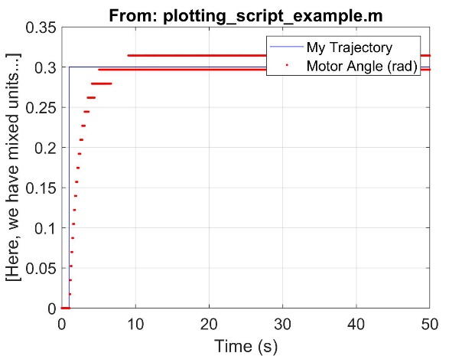

Forward Kinematics estimations:

